Kingston Data Traveler Exodia M USB Flash Drive 64GB USB 3.2 |DTXM/64GB (CZONE)

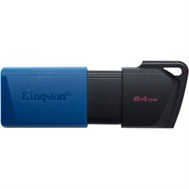

**Key Features**

* **64GB Storage Capacity**: With 64GB of storage, the Data Traveler Exodia M offers a good balance between cost and capacity, making it an ideal option for storing documents, photos, videos, music, and backups.
* **USB 3.2 Performance**: Supporting **USB 3.2** Gen 1 (backward compatible with USB 2.0), the Exodia M delivers fast transfer speeds, up to **100MB/s** for reading data, making it faster than older USB 2.0 drives for transferring large files.
* **Easy to Use**: The drive is plug-and-play, requiring no software or drivers to be installed. Simply plug it into a USB-A port on a compatible device, and it’s ready for use.

**Software and Compatibility**

* **Wide OS Compatibility**: The Data Traveler Exodia M is compatible with **Windows**, **macOS**, and **Linux** systems, as well as other devices with USB-A ports. It supports both **exFAT** and **FAT32** file systems, providing cross-platform compatibility.

**Warranty and Support**

* **5-Year Limited Warranty**: Kingston offers a **5-year limited warranty** on the Exodia M, ensuring the drive’s reliability and providing peace of mind for users who depend on it for storing important data.
* **Kingston Customer Support**: Kingston provides robust customer support, including product documentation, technical assistance, and troubleshooting resources through their website.